Obligatorisk opgave nr. 3: Base system.

This assignment is about making a system for a database so that information can quickly and effectively be gathered from set database and be presented for the user of the system.

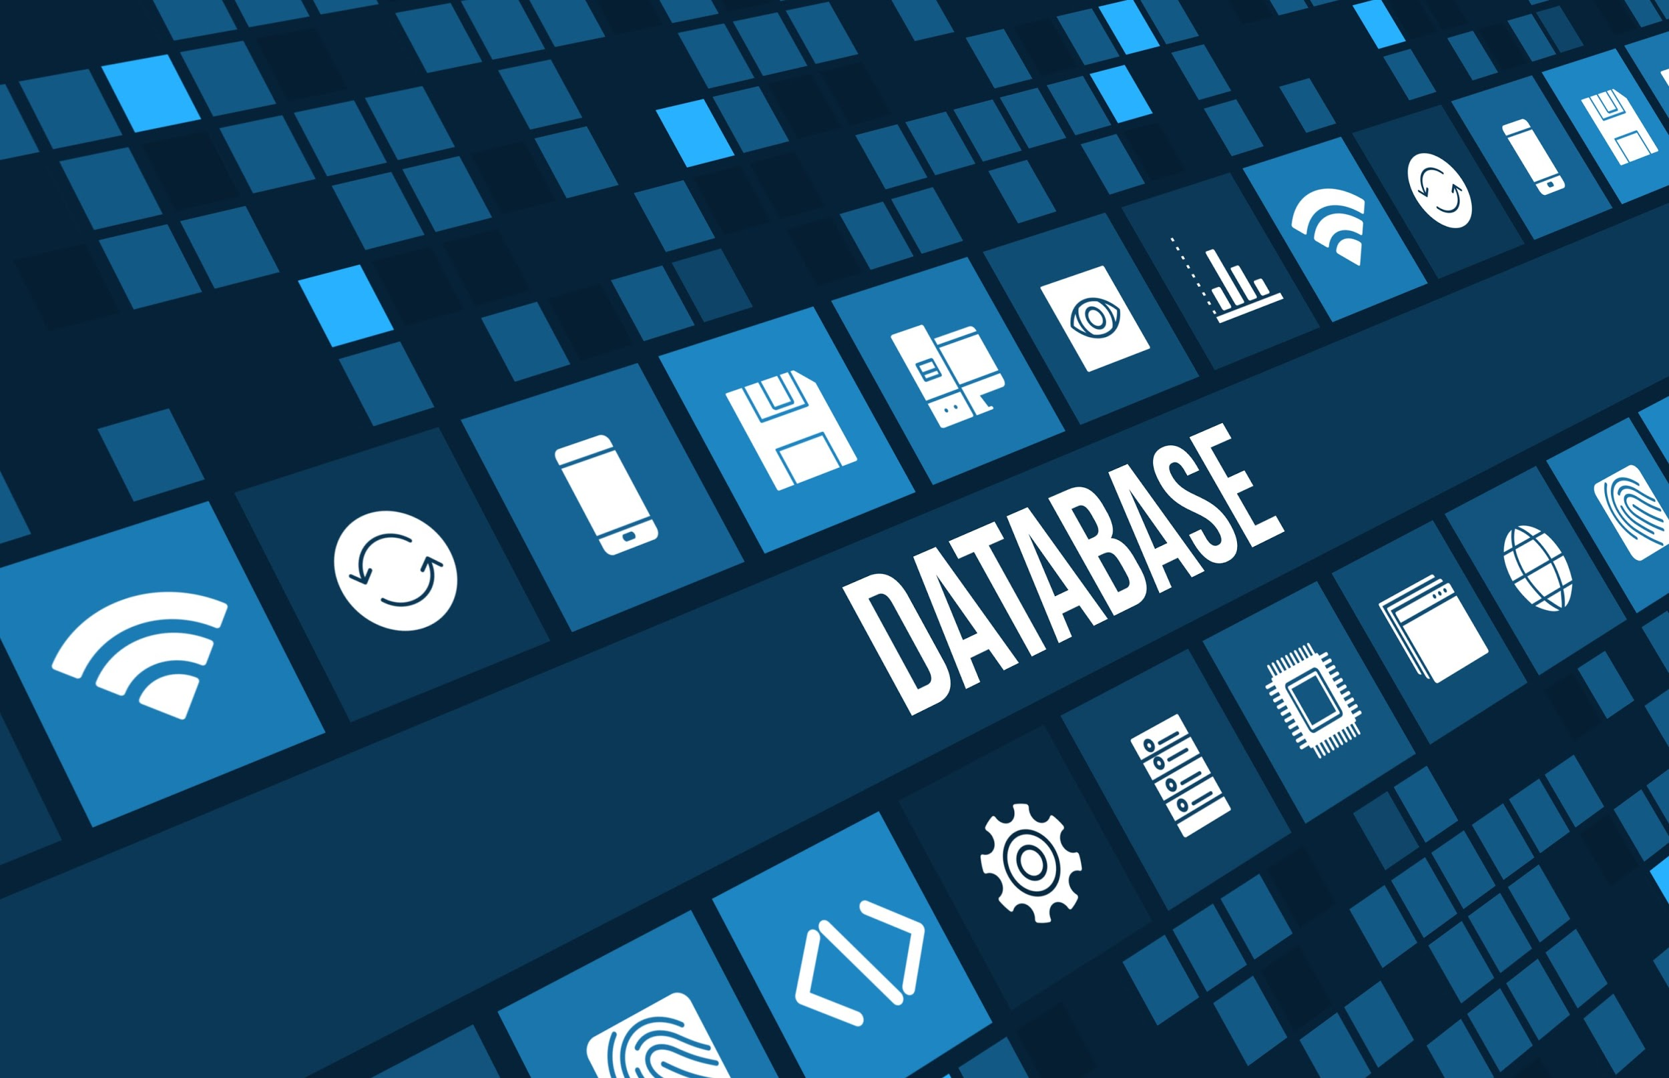

(Picture: 1 - See source in end of document)

# Indholdsfortegnelse / Content

**Indholdsfortegnelse / Content** **2**

Vision 3

Requirements 3

Glossary: 3

Use cases 4

Use case diagram 5

ERD - Entity Relation Diagram 6

Domain model 7

Activity diagram 8

System Sequence Diagram 9

SD 10

Class diagram 11

Gantt / Kanban 12

Litteraturliste / Sources 13

## 

## 

## 

## 

## 

## 

## 

## 

## Vision

Create a search function which can handle CRUD for our database.

## Requirements

* Software must assure the uniqueness of Primary Key and take appropriate action if rule is going to be violated.
* Create a new line in table.
* Search for item(s) in table.
* Update existing line(s) in table.
* Delete existing line(s) i in table

.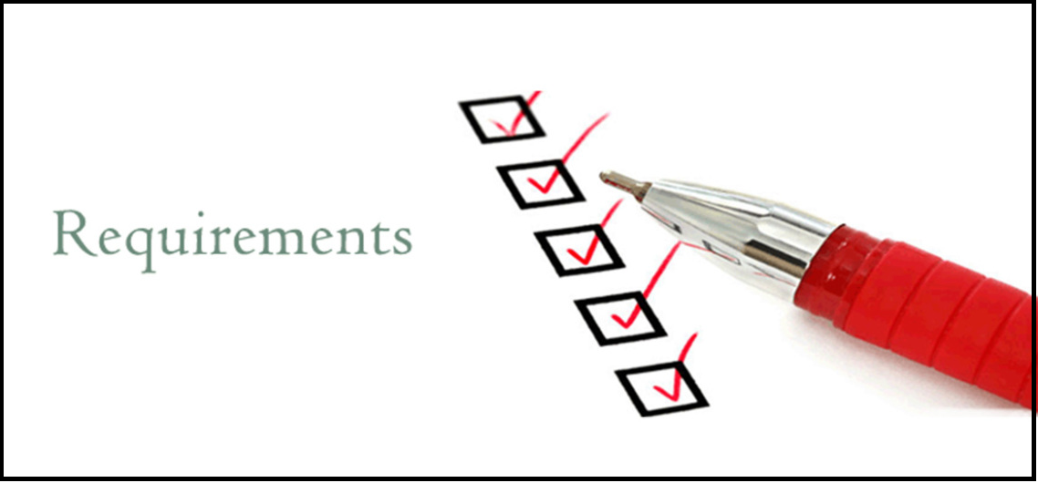

(Picture 2: - See source in end of document)

## Glossary:

-Search

-Read

## 

## Use cases

**Use cases:**

* Use case 1: Create new entry
* Use case 2: Update entry
* Use case 3: Delete entry
* Use case 4: Search database
* Use case 5: Read Entry.

**Use case 1. (Fully dressed)**

Title: Create new entry.

Scope: System, database.

Level: User goal.

Primary actors: Admin.

Stakeholders and interests:

* Admin

Main success scenario:

1. Actor picks menuitem; “Create entry” from options menu.
2. Actor picks table.
3. System generates a unique primary key.
4. System asks actor for input according to the table columns.
5. System verifies data types according to corresponding column.
6. User is presented with new data.
7. User confirms new data.
8. A new entry is added to the database.

Extensions:

5a. System declines data.

1. User types item again or cancels new entry.

7a. User declines new data.

1. New entry is deleted.

**Use case 2:**

Title: Update entry.

Primary actor: Admin.

Precondition: Use case 5.

Main success scenario:

* Actor chooses “Update” from menu.
* Actor inputs data according to the table columns.
* Actors confirms.
* System updates data.

**Use case 3:**

Title: Delete entry.

Primary actor: Admin.

Precondition: Use case 5

Main success scenario:

* Actor chooses menuitem; “delete”.
* Actor confirms deletion.
* System deletes entry.

**Use case 4:**

Title: Search database.

Primary actor: Admin.

Main success scenario:

1. Actor chooses tables.
2. Actor chooses columns.
3. Actor specifies values.
4. System searches database and displays new pseudo table.

**Use case 5:**

Title: Read entry

Primary Actor: Admin.

Main success scenario:

1. Actor chooses table
2. Actor enters searchterm.
3. System reads from database.
4. System returns entry.
5. System presents Update/delete menu for chosen entry.

## Use case diagram

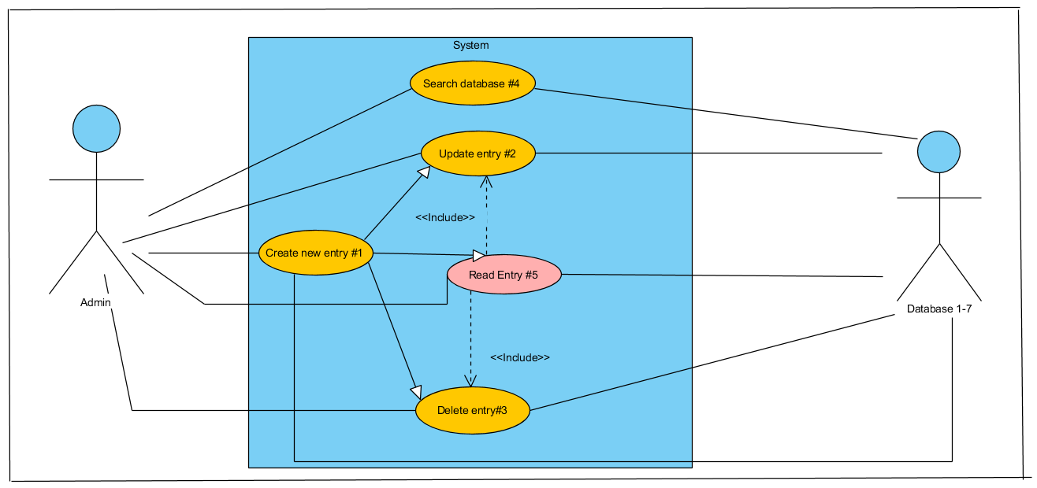

(Diagram 1: Use case diagram - Source in end of document)

## Domain model

## 

(Diagram 2: Domain Model - Source in end of document)

## Activity Diagram

## 

(Diagram 3: Activity Diagram- Source in end of document)

## SSD diagram

(Diagram 4: SSD Diagram- Source in end of document)

## System Sequence Diagram

(Diagram 5: SSD - Source in end of document)

## Class diagram

## 

(Diagram 6: Class Diagram- Source in end of document)

## Gantt / Kanban

## 

## (Diagram 6: Gantt / Kanban- Source in end of document)

## 

## 

## 

## 

## Litteraturliste / Sources

Pictures:

picture: 1. Source - <https://www.insightsintoimpact.com/its-just-a-database/database-graphic-hi-res/>

picture: 2. Source - <http://www.windsor.edu/admissions/requirements/>

Diagrams:

Diagram: 1. Source - Made it ourselves in visual paradigm.

Diagram: 2. Source - Made it ourselves in visual paradigm.

Diagram: 3. Source - Made it ourselves in visual paradigm.

Diagram: 4. Source - Made it ourselves in visual paradigm.

Diagram: 5. Source - Made it ourselves in visual paradigm.

Diagram: 6. Source - Made it ourselves in docs.